## Front End Engineering-II

Project Report

Semester-IV (Batch-2022)

Foodies-Food ordering website

**Supervised By: Submitted By:**

Faculty Name Kashish Barthwal, 2210990495(G-10)

Joel Matthew,2210990465(G-10)

Jugal Kishor, 2210990467(G-10)

Kanwar Marzara, 2210990473(G-10)

**Department of Computer Science and Engineering**

## Chitkara University Institute of Engineering & Technology,

## Chitkara University, Punjab

**Abstract**

The "Foodies" project is a frontend-driven endeavour aimed at revolutionizing the online food ordering experience. Unlike conventional food ordering platforms, "Foodies" focuses solely on providing users with an immersive and visually captivating interface for browsing, selecting, and managing food items.

At its core, "Foodies" embodies simplicity and elegance, leveraging the latest advancements in web development technologies such as HTML, CSS, JavaScript, and ReactJS. Through meticulous design and meticulous attention to detail, the project seeks to redefine the boundaries of user interaction within the realm of food ordering.

Key elements of the "Foodies" platform include a seamless navigation experience, a diverse and expansive menu display, and intuitive cart management functionality. Users are empowered to explore a myriad of culinary options from various restaurants, effortlessly adding their desired items to the cart with just a few clicks or taps.

The project's methodology revolves around structuring the frontend architecture to optimize performance and scalability. By adhering to best practices and implementing efficient algorithms for cart management, "Foodies" aims to deliver a fluid and responsive user experience across all devices and screen sizes.

In conclusion, "Foodies" represents a paradigm shift in the way users interact with online food ordering platforms. Through its innovative design, user-centric approach, and commitment to excellence, the project sets out to redefine industry standards and elevate the overall dining experience for food enthusiasts worldwide.

**Table of Contents**

|  |
| --- |
| 1. Introduction 2. Problem Definition and Requirements 3. Proposed Design / Methodology 4. Results 5. References |

1. **Introduction**

**1.1 Background**

The advent of technology has significantly transformed various sectors, and the food industry is no exception. In recent years, online food ordering systems have revolutionized the way people order food, offering unprecedented convenience and efficiency. Traditional methods of food ordering, such as phone calls or in-person visits to restaurants, are gradually being replaced by online platforms that enable customers to browse menus, place orders, and make payments from the comfort of their homes. This shift has been accelerated by the widespread use of smartphones and the internet, making online food ordering a vital component of modern life.

The project titled "Foodies" is a comprehensive food ordering website designed to cater to the growing demand for online food services. Developed using HTML, CSS, JavaScript, ReactJS, and API fetching concepts, "Foodies" aims to provide an intuitive and seamless user experience for both customers and restaurant owners. By leveraging modern web development technologies, "Foodies" offers a robust platform for users to explore a wide range of culinary options, place orders, and receive timely deliveries.

Our project brings the ease of modern food delivery services directly to your fingertips. With a user-friendly design and robust features, our platform enables users to explore menus, customize orders, and complete transactions with ease, all from the comfort of their own device.

Join us on a culinary journey like no other as we redefine the food ordering experience for the digital age. With our Food web, delicious dining experiences are just a few taps away, waiting to be enjoyed whenever and wherever you desire. Welcome to a new era of convenient and delightful food ordering - welcome to our Food web.

**1.2 Objectives**

The primary objectives of the "Foodies" project are as follows:

1. **User-Friendly Interface:**

Our goal is to design a website with an intuitive and responsive interface that facilitates easy navigation and enhances the user experience. The interface should be aesthetically pleasing and accessible on various devices, including desktops, tablets, and smartphones. The design will focus on clarity, simplicity, and ease of use, ensuring that users can effortlessly browse through menus, select items, and complete orders.

1. **Working Navigation:**

Ensuring seamless navigation throughout the website is critical. "Foodies" will implement a well-structured and logical navigation system that allows users to move easily between different sections of the site. This includes a clear and concise menu structure, breadcrumbs for easy backtracking, and a search function to quickly find specific items or information. Effective navigation will help users find what they are looking for quickly, enhancing their overall experience.

1. **Add to Cart Feature:**

A robust "Add to Cart" feature is essential for an effective food ordering system. This feature will allow users to select multiple items from different sections of the menu and add them to their cart. The cart will display a summary of selected items, including quantities and prices, and will provide options to modify orders before finalizing the purchase. This functionality will be designed to be user-friendly and efficient, ensuring a smooth ordering process.

1. **Diverse Variety:**

"Foodies" aims to offer a diverse variety of food options to cater to different tastes and preferences. The website will feature menus from multiple restaurants, covering a wide range of cuisines and dietary requirements. This diversity will include options for vegetarian, vegan, gluten-free, and other dietary needs, ensuring that all users can find something that suits their preferences.

**1.3 Significance**

The "Foodies" food ordering website project holds significant potential to impact the online food service industry positively. By focusing on key objectives such as a user-friendly interface, working navigation, add to cart feature, and diverse variety, "Foodies" addresses crucial aspects of user experience and operational efficiency. Here is the significance of these objectives:

1. **User-Friendly Interface:**

The significance of a user-friendly interface lies in its ability to attract and retain customers. An intuitive and responsive design ensures that users, regardless of their technical proficiency, can easily navigate the website, browse menus, and place orders. This ease of use enhances customer satisfaction and increases the likelihood of repeat business. By providing a pleasant and hassle-free ordering experience, "Foodies" can build a loyal customer base and establish a strong brand presence in the competitive online food ordering market.

1. **Working Navigation:**

Effective navigation is critical for providing a seamless user experience. A well-organized navigation system helps users find what they need quickly and efficiently, reducing frustration and improving overall satisfaction. For restaurant owners, this means customers are more likely to complete their orders, leading to higher conversion rates and increased sales. By ensuring that users can effortlessly move between different sections of the website, "Foodies" enhances user engagement and makes the ordering process straightforward and enjoyable.

1. **Add to Cart Feature:**

The "Add to Cart" feature is fundamental to any e-commerce platform, including a food ordering website. This feature allows users to select multiple items, review their selections, and make changes before finalizing their orders. It streamlines the ordering process, making it convenient for customers to manage their choices. For restaurants, a robust "Add to Cart" feature reduces order errors and improves order accuracy, leading to better customer satisfaction and operational efficiency. This functionality is crucial for handling high volumes of orders and ensuring a smooth transaction process.

1. **Diverse Variety:**

Offering a diverse variety of food options is essential to cater to the wide-ranging preferences and dietary needs of customers. By featuring menus from multiple restaurants and including options for various cuisines and dietary requirements (e.g., vegetarian, vegan, gluten-free), "Foodies" broadens its appeal and attracts a larger audience. This diversity not only enhances the user experience by providing more choices but also supports restaurants in reaching new customer segments. By showcasing a wide array of culinary options, "Foodies" can position itself as a versatile and inclusive platform that meets the needs of all users.

1. **Problem Definition and Requirements**

**2.1 Problem Statement**

The rapid evolution of technology and the increasing demand for convenience have significantly transformed consumer behaviour in the food industry. Traditional methods of ordering food, such as phone calls or in-person visits to restaurants, are increasingly being replaced by online platforms that offer greater ease and efficiency. However, many existing online food ordering systems are plagued by issues such as poor user interfaces, inefficient navigation, limited menu options, and lack of real-time order tracking. These problems can lead to customer dissatisfaction, reduced sales, and operational inefficiencies for restaurants.

The "Foodies" project aims to address these challenges by developing a comprehensive food ordering website that leverages modern web development technologies. The goal is to create an intuitive, user-friendly platform that enhances the online food ordering experience for customers while streamlining order management and operations for restaurants.

**2.2 Requirements**

1. **Frontend Development:**

**HTML5:** For structuring the content and layout of the website.

**CSS3**: For styling the website and ensuring a responsive design that works across various devices.

**JavaScript:** For adding interactive elements and functionality to the website.

**ReactJS:** As the primary framework for building a dynamic and efficient user interface. ReactJS will enable the development of reusable components and facilitate state management.

1. **Development Tools:**

**Visual Studio Code:** As the primary code editor for development.

**Git:** For version control and collaboration among team members.

1. **Data Sets:**

**Menu Data:** Comprehensive menus for each restaurant, including item names, descriptions, prices, images, and categories (e.g., appetizers, main courses, desserts).

1. **Proposed Design / Methodology**

Given that the "Foodies" project is a frontend GUI-based website with no backend involvement for order processing or payments, the design and methodology will focus solely on the client-side functionality. This section will outline the design and functionality related to adding items to the cart without further processing orders or payments, including the schematic diagram, file structure, and algorithms used.

1. **Schematic Diagram**

The schematic diagram of the "Foodies" system will illustrate the user interaction for adding items to the cart and viewing the cart contents.

**Schematic Diagram Components:**

**Client Side:** User interface built with HTML, CSS, and ReactJS, where users browse items and add them to the cart.

**Cart Management**: Local state or context in ReactJS to manage the items added to the cart.

1. **File Structure**

The file structure of the "Foodies" project will focus on organizing components related to the cart functionality within the ReactJS application.

foodies/

├── public/

│ ├── index.html

│ ├── favicon.ico

│ └── ...

├── src/

│ ├── components/

│ │ ├── Header.js

│ │ ├── Footer.js

│ │ ├── Menu.js

│ │ ├── Cart.js

│ │ ├── CartItem.js

│ │ └── ...

│ ├── pages/

│ │ ├── Home.js

│ │ ├── Restaurant.js

│ │ └── ...

│ ├── context/

│ │ ├── CartContext.js

│ │ └── ...

│ └── services/

│ ├── api.js

│ └── ...

├── package.json

└── ...

1. **Cart Functionality**

**Algorithm for Adding Items to Cart:**

1. When a user clicks on the "Add to Cart" button for an item:

Retrieve the item details (name, price, quantity) from the UI.

Add the item to the cart by updating the cart state or context in ReactJS.

Update the cart UI to reflect the added item.

**Algorithm for Removing Items from Cart:**

1. When a user clicks on the "Remove" button for an item in the cart:

Retrieve the item details (name, price, quantity) from the UI.

Remove the item from the cart by updating the cart state or context in ReactJS.

Update the cart UI to reflect the removed item.

The proposed design and methodology for the "Foodies" project focus on creating a user-friendly frontend GUI-based website for browsing and adding items to the cart. With a clear schematic diagram, well-organized file structure, and defined algorithms for cart functionality, the project aims to deliver a seamless and enjoyable user experience for browsing and selecting food items.

1. **Results**

Following are the results of our website:

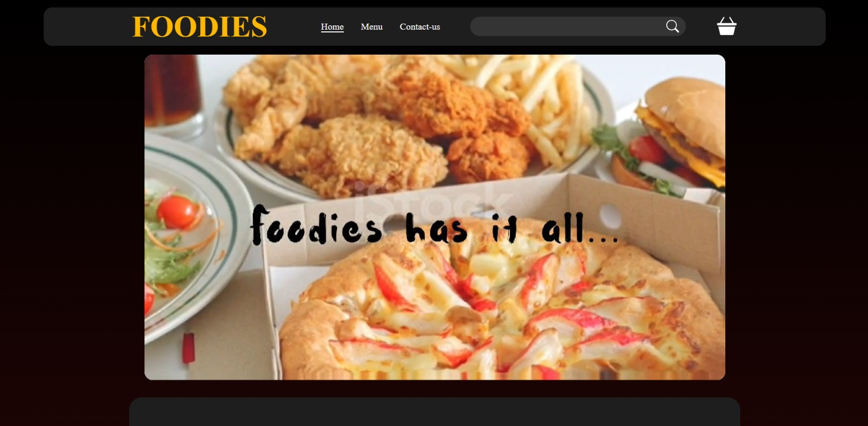

This our home page. Here on the top, there is a working navigation bar with an animated logo of our website and a video of our website.

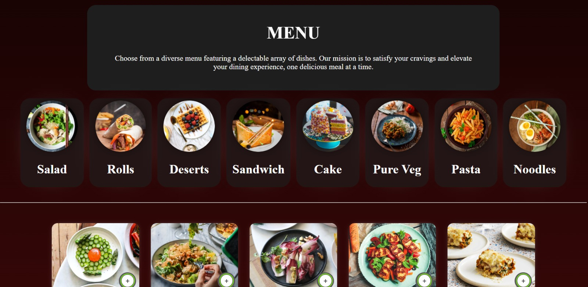

This is the menu section of our website. Here customer can select and sort from our diverse variety according to their choice.

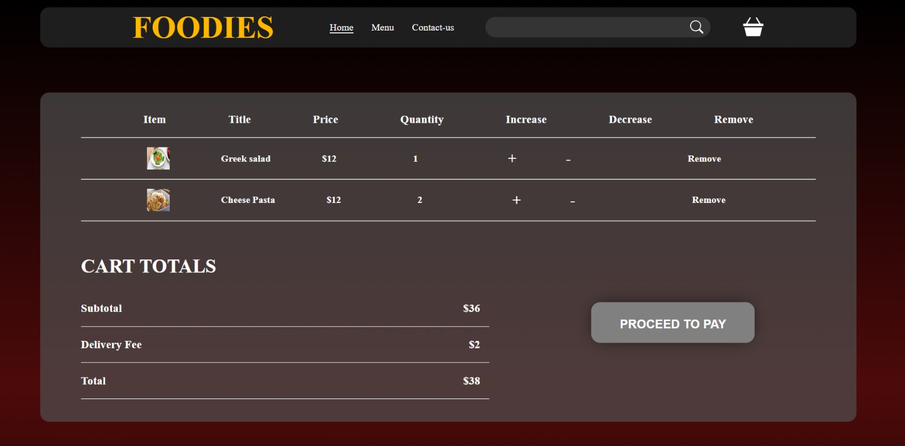

This is our cart component in these items selected by users are displayed along with the quantity.

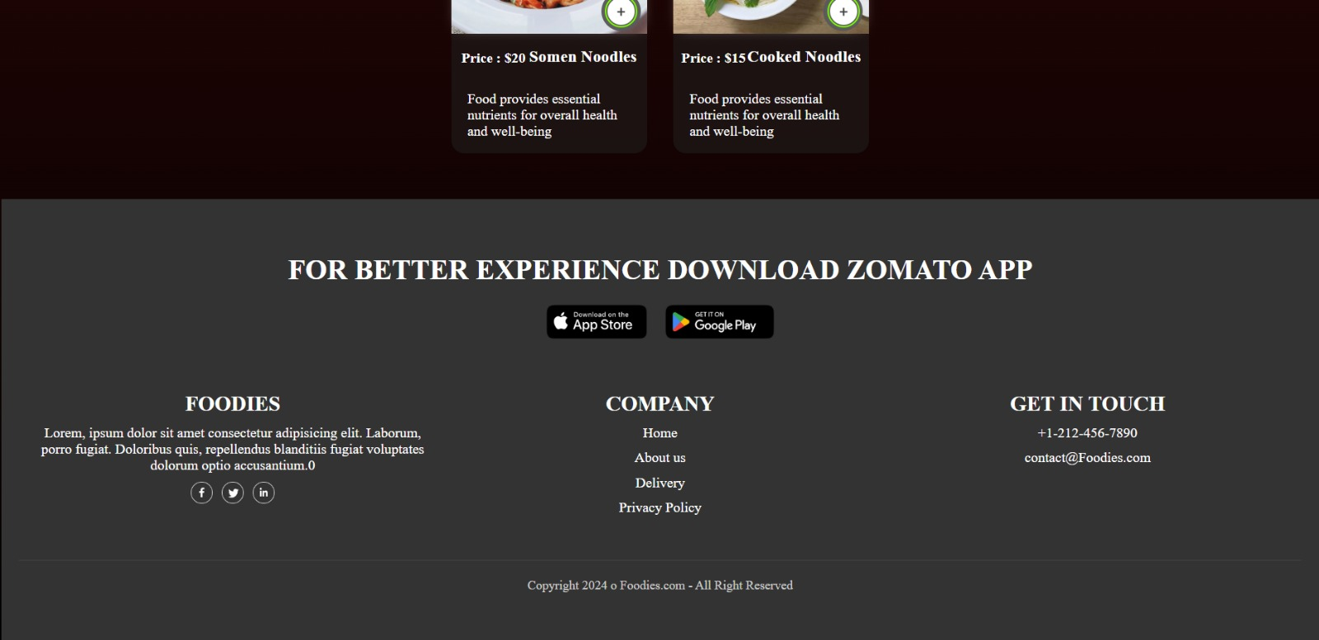

This the footer of our website where user can contact us whenever they need.

1. **References**

References of this project have been taken from the below mentioned sites:

* [**https://www.w3schools.com/**](https://www.w3schools.com/)
* [**https://www.youtube.com/**](https://www.youtube.com/)
* [**https://www.geeksforgeeks.org/**](https://www.geeksforgeeks.org/)
* **https://www.tutorialspoint.com/**
* **https://en.wikipedia.org/wiki/**